**How we keep your personal information safe:**

**We have a duty to:**

* Maintain full and accurate records of the care we provide;
* Keep records about you confidential, secure and accurate;
* Provide information in a format that is accessible to you (*i.e.*, in large type if you are partially sighted).

We **will not** share information that identifies you for any reason, unless:

* you ask us to do so;
* we ask and you give us specific permission;
* we have to do this by law;
* we have special permission for health or research purposes

We may share your information, with yourconsentand always in line with our information sharing procedures, with:

1. Social Services
2. Hospital Services
3. Local Authorities
4. Your GP
5. Your family or representative

Anyone who receives information from us also has a legal duty to keep it confidential.

**If you require this leaflet in a different format or you need further information or assistance, please contact:**

**Emily Douse**

**trinityprojectmanager@gmail.com**

**01727 838671**

**Keeping Your Information Safe!**

This leaflet explains:

* How we keep your personal information confidential
* Who we share information with
* How we use your information
* How you can access your records

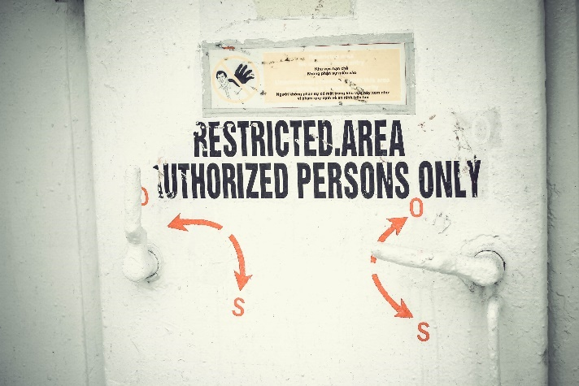

**Why we collect information about you:**

We aim to provide you with the highest quality of care. To do this we must have access to your medical records and keep care plans to monitor and improve your daily care.

These records may include:

* Basic details about you, such as address, date of birth, next of kin
* Contact we have had with you such as clinical visits
* Notes and reports about your health
* Details and records about your treatment and care
* Relevant information from people who care for you and know you well, such as care professionals and relatives

It is our promise to you that we will:

* discuss and agree what we record about you
* give you access to your records whether digital or paper based
* keep you informed about, and ensure that, you have input into your care plan

Your records with us may be stored on paper or on the computer – if you would like to know what measures we have to keep your records safe, please ask!

The people who care for you use your records to:

* Provide a good basis for all health decisions made by you and care professionals
* Allow you to work with those providing care
* Make sure your care is safe and effective, and
* Work effectively with others providing you with care

Others may also need to use records about you to:

* Check the quality of care (such as clinical audit)
* Protect the health of the general public
* Manage social care services
* Help investigate any concerns or complaints you or your family have about your care

We always seek your consent before sharing any aspect of your personal information. If you are not able to provide consent, your representative with an appropriate power of attorney or the clinical team can make a decision in your best interests.

**How we use your records:**

You have the right to confidentiality under the Data Protection Act 1998 (DPA), the Human Rights Act 1998 and the common-law duty of confidentiality (the Disability Discrimination and the Race Relations Acts may also apply).

You have the right to ask for a copy of all records about you. Please speak to a member of staff to see your records. If you think anything is inaccurate or incorrect, please let us know.

**Notification:**

Social Care information sharing is subject to the principles which have been set out by the National Data guardian in the Caldicott Reports of 2013 and 2016.

The Data Protection Act 1998 requires organisations to notify the Information Commissioner’s Office (ICO) of the purposes for which they process personal information: [www.ico.org.uk](http://www.ico.org.uk)

If you have any concerns or questions about the use of your personal information please let us know.

**Your rights:**